WebGrants – Quick Navigation:
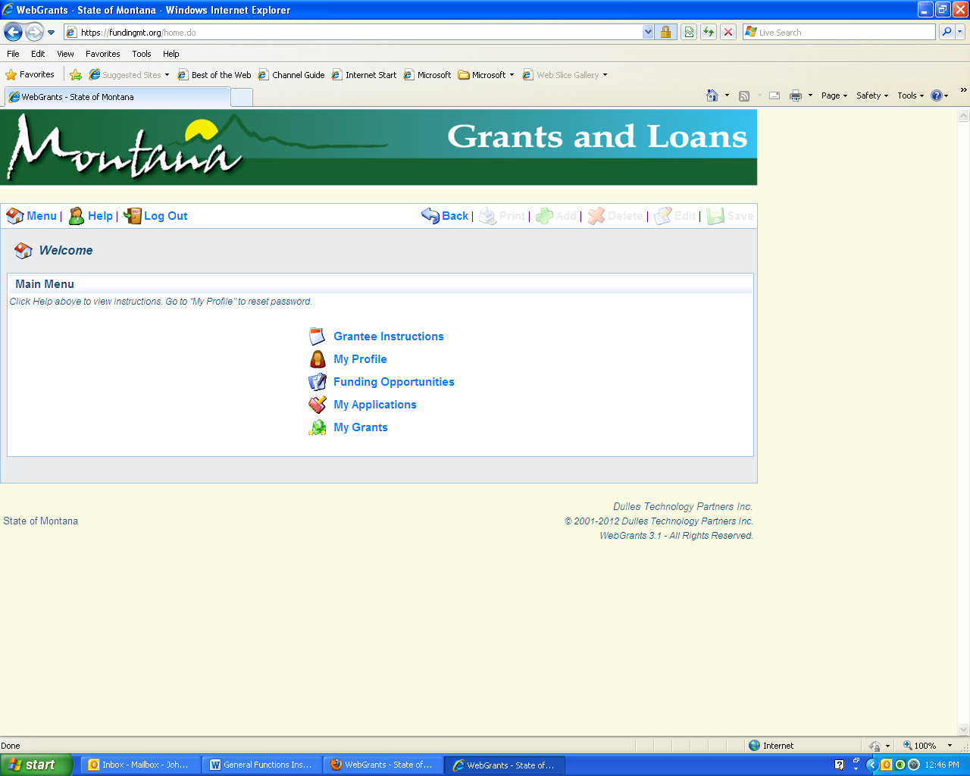
Return to the main menu
Log out of Webgrants
Return to the previous menu
***Do not use your browser’s back button

Change password, update
contact info, & add people
Start new application
Current applications: edit, submit, correct
Manage grants: status reports, claims, revised budgets, & grant extension requests
General information about WebGrants

