WebGrants Registration Instructions
Read ALL instructions before registering!
Go to the following website https://fundingmt.org to register yourself and the organization you work for, click on “Register Here”. If there are multiple people working for the same organization that is applying for a funding opportunity, only enter the primary contact person for that organization. Additional people can be added to the organization after the primary contact person gets the login information from the WebGrants system.
If a grant writer from a local economic development organization is assisting you with the development of an application, that person should also register individually with their own organization and an email should be sent to jauer@mt.gov from the applicant organization authorizing the grant writer(s) to be granted access to the application. Please call Jim Auer at 444-5424 if you have questions.
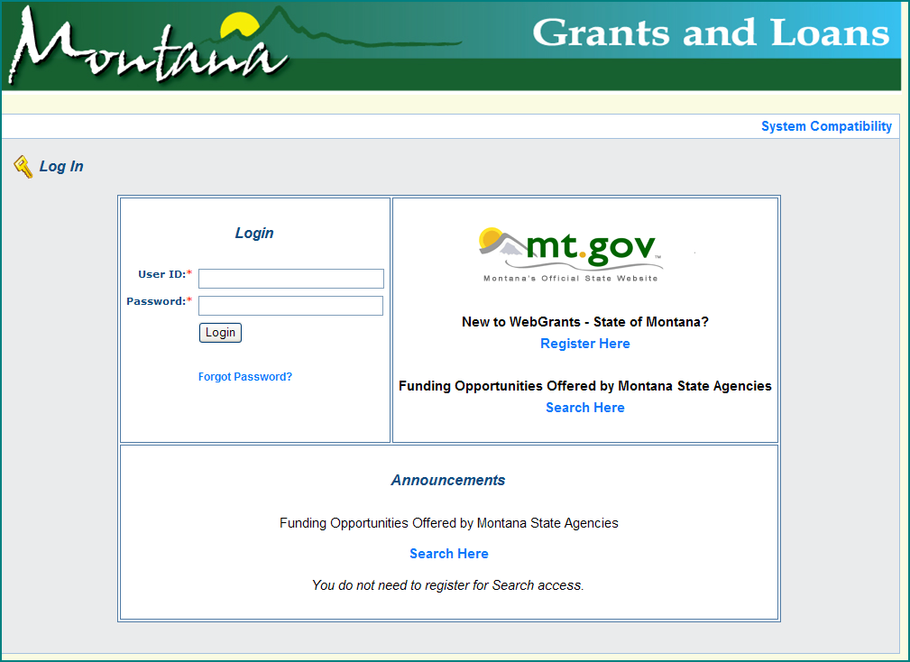
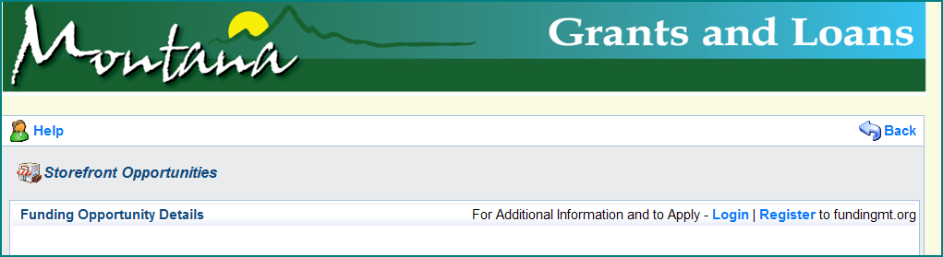

Complete the required information on the form and then click on “Register” at the top or bottom of the form. The titles with a red astrisk by them indicate the field is required.
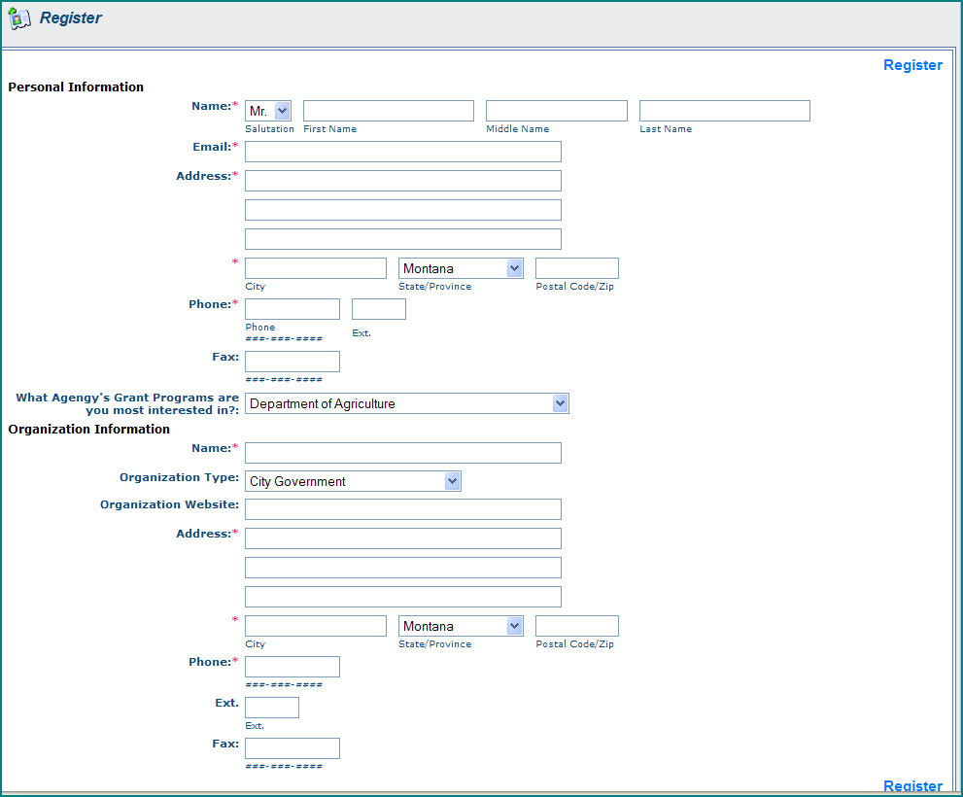
Click on the little down arrow and select “Department of Agriculture”.
Do not enter dashes in the phone & fax numbers.
Do not enter dashes in the phone & fax numbers.

Continue completing the Organization Information then click on “Register” to submit your registration. The Department of Agriculture must approve your registration before WebGrants will send you your User ID and password. This process may take several business days to receive your login information, so please be patient. Please contact Jim Auer at 406-444-5424 if you have any questions or problems with registration process. Thank you!

